UNIT IV ROUTING
Routing and protocols: Unicast routing - Distance Vector Routing - RIP - Link State Routing – OSPF– Path-vector routing - BGP - Multicast Routing: DVMRP – PIM.

Routing:
- Routing is defined as the process of selecting the path along which the data can be transferred from source to the destination. Routing is performed by a special device known as a router.
- A router is a networking device that forwards the packet based on the information available in the packet header and forwarding table.
- The routing algorithms are used for routing the packets.
- The routing protocols use the metric such as hop count, bandwidth, delay, current load on the path to determine the best path for the packet delivery.
- The routing algorithm initializes and maintains the routing table for the process of path determination.
- Routing protocols are divided into two categories such as intra domain routing and inter domain routing
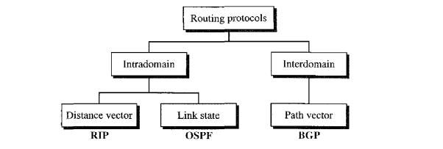
- Routing inside an autonomous system is referred to as intradomain routing.
- Routing between autonomous systems is referred to as interdomain routing
Unicast routing:
- In unicast communication, there is one source and one destination. The relationship between the source and the destination is one-to-one.
- In this type of communication, both the source and destination addresses, in the IP datagram, are the unicast addresses.
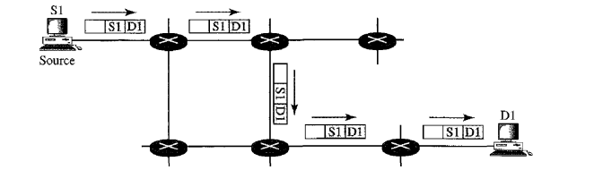
- when a router receives a packet, it forwards the packet through only one of its interfaces (the one belonging to the optimum path) as defined in the routing table.
- The router may discard the packet if it cannot find the destination address in its routing table.
Multicast Routing:
- In multicast communication, there is one source and a group of destinations.
- The relationship is one-to-many. In this type of communication, the source address is a unicast address, but the destination address is a group address, which defines one or more destinations. The group address identifies the members of the group.
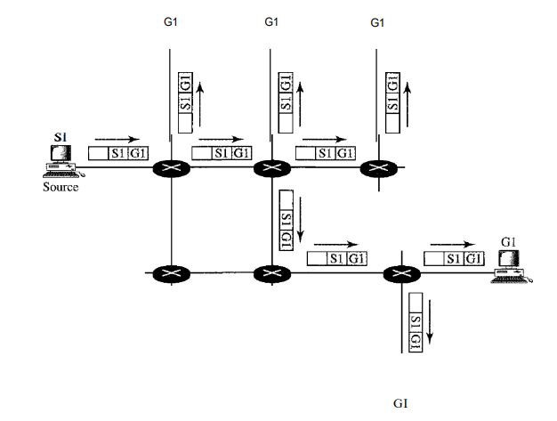
- A multicast packet starts from the source S1 and goes to all destinations that belong to group G1. In multicasting, when a router receives a packet, it may forward it through several of its interfaces.

4.1 Distance Vector routing: (Q2(B)Explain what is Distance Vector Routing? and Demonstrate how distance table gives routing table.)
- In distance vector routing, the least-cost route between any two nodes is the route with minimum distance.
- Each node maintains a vector (table) of minimum distances to every node.
- The table at each node also guides the packets to the desired node by showing the next stop in the route (next-hop routing).
- A multicast packet starts from the source S1 and goes to all destinations that
belong to group G1. In multicasting, when a router receives a packet, it may forward it through several of its interfaces.

Initialization:
- Initially each node can know only the distance between itself and its immediate neighbor’s, those directly connected to it.
- The distance for any entry that is not a neighbour is marked as infinite (unreachable).
- The table for node A shows how we can reach any node from this node. For example, our least cost to reach node E is 6. The route passes through C.
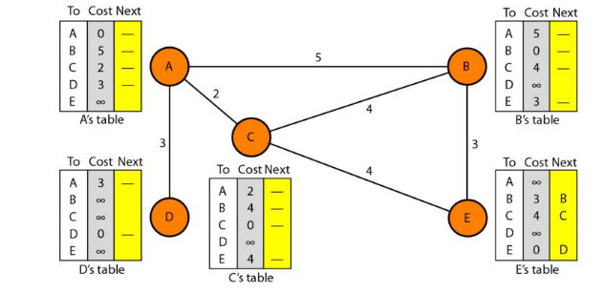
Fig: Distance vector routing: Initialization
Sharing:
- In distance vector routing, each node shares its routing table with its immediate neighbour's periodically and whenever there is a change.
- Although node A does not know about node E, node C knows. So, if node C shares its routing table with A, node A can also know how to reach node E.
- On the other hand, node C does not know how to reach node D, but node A knows. If node A shares its routing table with node C, node C also knows how to reach node D.
- The third column of a table (next stop) is not useful for the neighbour. A node therefore can send only the first two columns of its table to any neighbour.
Updating:
- When a node receives a two-column table from a neighbour, it needs to update its routing table.
- Updating can be done in three steps:
1. The receiving node (A) needs to add the cost between itself and the sending node (C) to each value in the second column. If node C claims that its distance to a destination is x, and the distance between A and C is y,then the distance between A and that destination, via C, is x + y.
2. The receiving node needs to add the name of the sending node to each row as the third column if the receiving node uses information from any row.The sending node is the next node in the route.
3. The receiving node needs to compare each row of its old table with the corresponding row of the modified version of the received table.
a. If the next-node entry is different, the receiving node chooses the row with the smaller cost. If there is a tie, the old one is kept.
b. If the next-node entry is the same, the receiving node chooses the new row. For example, suppose node C has previously advertised a route to node X with distance 3. Suppose that now there is no path between C and X; node C now advertises this route with a distance of infinity. Node A must not ignore this value even though its old entry is smaller. The old route does not exist anymore. The new route has a distance of infinity.
- The below fig shows how node A updates its routing table after receiving the partial table from node C
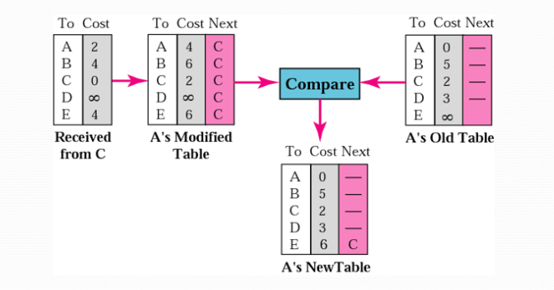
- A node sends its partial routing table to the neighbours both periodically and whenever there is a change in the table.
Periodic Update: A node sends its routing table, normally every 30 s, in a periodic update. The period depends on the protocol that is using distance vector routing.
Triggered Update: A node sends its two-column routing table to its neighbor’s anytime when there is a change in its routing table. This is called a triggered update. The change can result from the following.

1. A node receives a table from a neighbor, resulting in changes in its own table after updating.
2. A node detects some failure in the neighbouring links which results in a distance change to infinity.
Two-Node Loop Instability:
- A problem with distance vector routing is instability, which means that a network using this protocol can become unstable.
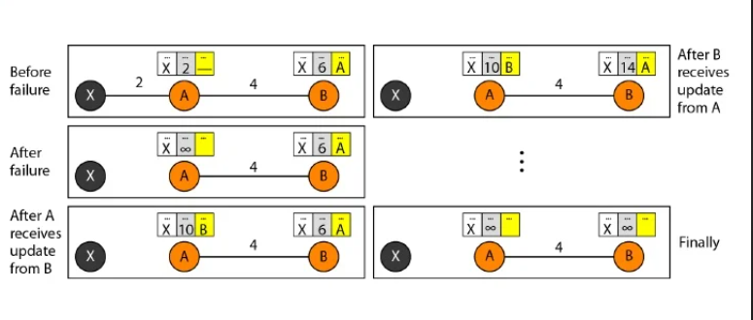
- The above figure shows a system with three nodes. At the beginning, both nodes A and B know how to reach node X.
- But suddenly, the link between A and X fails. Node A changes its table.
- If A can send its table to B immediately, everything is fine. However, the system becomes unstable if B sends its routing table to A before receiving A's routing table.
- Node A receives the update and, assuming that B has found a way to reach X, immediately updates its routing table.
- Based on the triggered update strategy, A sends its new update to B. Now B thinks that something has been changed around A and updates its routing table.
- The cost of reaching X increases gradually until it reaches infinity.
- Packets bounce between A and B, creating a two-node loop problem.
- A few solutions have been proposed for instability of this kind.

1. Defining Infinity:
- The first obvious solution is to redefine infinity to a smaller number, such as 100. After a cost of 100 is reached the cost must be changed to infinity.
2. Split Horizon:
- In this strategy, instead of flooding the table through each interface, each node sends only part of its table through each interface. If, node B thinks that the optimum route to reach X is via A, it does not need to advertise this piece of information to A.
- Node B eliminates the last line of its routing table before it sends it to A.
- In this case, node A keeps the value of infinity as the distance to X. Later when node A sends its routing table to B, node B also corrects its routing table.
- The system becomes stable after the first update: both node A and B know that X is not reachable.
3. Split Horizon and Poison Reverse:
- Using the split horizon strategy has one drawback. Normally, the distance vector protocol uses a timer, and if there is no news about a route, the node deletes the route from its table. When node B in the previous scenario eliminates the route to X from its advertisement to A, node A cannot guess that this is due to the split horizon strategy (the source of information was A) or because B has not received any news about X recently. The split horizon strategy can be combined with the poison reverse strategy. Node B can still advertise the value for X, but if the source of information is A, it can replace the distance with infinity as a warning: "Do not use this value; what I know about this route comes from you."
Three-Node Instability:
- The two-node instability can be avoided by using the split horizon strategy combined with poison reverse. However, if the instability is between three nodes, stability cannot be guaranteed.
- Suppose, after finding that X is not reachable, node A sends a packet to B and C to inform them of the situation. Node B immediately updates its table, but the packet to C is lost in the network and never reaches C.
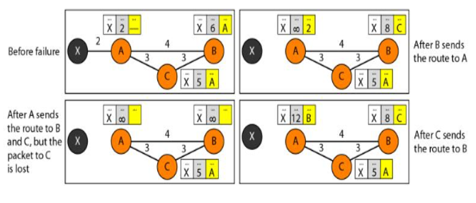
- Node C still thinks that there is a route to X via A with a distance of 5.
- After a while, node C sends to B its routing table, which includes the route to X.
- Node B is totally fooled here. It receives information on the route to X from C, and according to the algorithm, it updates its table, showing the route to X via C with a cost of 8.
- This information has come from C, not from A, so after a while node B may advertise this route to A.
- Now A is fooled and updates its table to show that A can reach X via B with a cost of 12.
- Of course, the loop continues; now A advertises the route to X to C, with increased cost, but not to B. Node C then advertises the route to B with an increased cost. Node B does the same to A. And so on. The loop stops when the cost in each node reaches infinity.
4.2 Routing Information Protocol:
- The Routing Information Protocol (RIP) is an intradomain routing protocol used inside an autonomous system.
- It is a very simple protocol based on distance vector routing.
- Routing Information Protocol (RIP) uses hop count as a routing metric to find the best path between the source and the destination network.
- Hop count is the number of routers occurring in between the source and destination network. The path with the lowest hop count is considered as the best route to reach a network and therefore placed in the routing table.
- RIP implements distance vector routing directly with some considerations:
1. An autonomous system, consists of routers and networks (links). The routers have routing tables.
2. The destination in a routing table is a network, which means the first column defines a network address.
3. The metric used by RIP is the distance which is defined as the number of links (networks) to reach the destination.
4. Infinity is defined as 16, which means that any route in an autonomous system using RIP cannot have more than 15 hops.
5. The next-node column defines the address of the router to which the packet is to be sent to reach its destination.
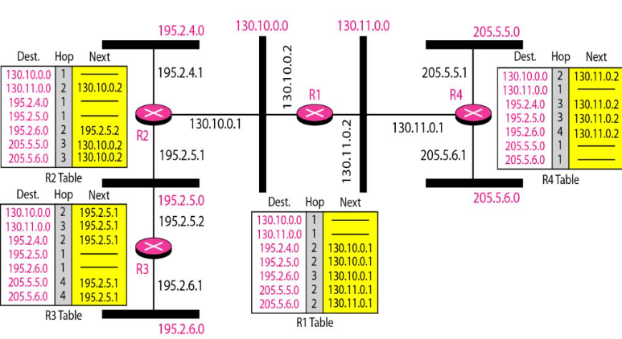
- The above figure shows an autonomous system with seven networks and four routers.
- The Routing table of R1 has seven entries to show how to reach each network in the autonomous system.
- Router Rl is directly connected to networks 130.10.0.0 and 130.11.0.0, which means that there are no next-hop entries for these two networks.
- To send a packet to one of the three networks at the far left, router Rl needs to deliver the packet to R2.
- The next-node entry for these three networks is the interface of router R2 with IP address 130.10.0.1.
- To send a packet to the two networks at the far right, router Rl needs to send the packet to the interface of router R4 with IP address 130.11.0.1.
4.3 Link State Routing: ( Q1(B)-Discuss about Link-state routing and routers.)
- Link state routing is a Intra domain routing method in which each router shares its neighbourhood’s knowledge with every other router in the internetwork.
- In this algorithm, each router in the netwo rk understands the network topology then makes a routing table based on this topology.
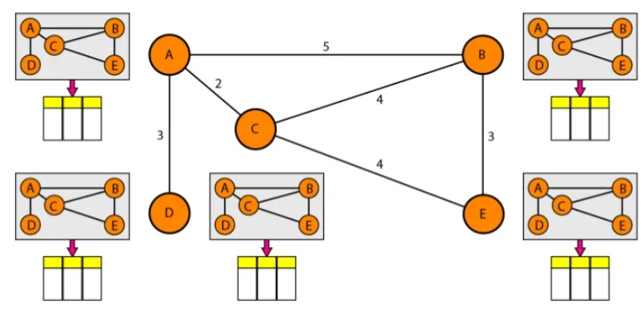
- Each router will share data about its connection to its neighbour, who will, consecutively, reproduce the data to its neighbours, etc.
- The topology must be dynamic, representing the latest state of each node and each link.
- If there are changes in any point in the network (a link is down, for example), the topology must be updated for each node.
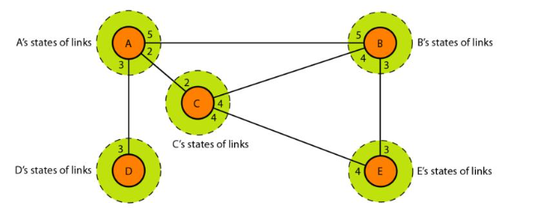
Building Routing Tables:
- In link state routing, four steps are required to ensure that each node has the routing table with the least-cost node to every other node.
1. Creation of the states of the links by each node, called the link state packet (LSP).
2. Dissemination of LSPs to every other router, called flooding, in an efficient and reliable way.
3. Formation of a shortest path tree for each node.
4. Calculation of a routing table based on the shortest path tree.
1. Creation of Link State Packet (LSP):
- A link state packet can carry a large amount of information such as the node identity, the list of links, a sequence number, and age.
- The node identity and the list of links, are needed to make the topology.
- The sequence number facilitates flooding and distinguishes new LSPs from old ones.
- The age prevents old LSPs from remaining in the domain for a long time.
- LSPs are generated on two occasions:
1. Triggered update: When there is a change in the topology of the domain. Triggering of LSP dissemination is the main way of quickly informing any node in the domain to update its topology.
2. Periodic update: On a periodic basis. The period in this case is much longer compared to distance vector routing. It is done to ensure that old information is removed from the domain.
2. Flooding of LSPs - After a node has prepared an LSP, it must be disseminated to all other nodes, not only to its neighbors. The process is called flooding and involves the following steps.
1. The creating node sends a copy of the LSP out of each interface.
2. A node that receives an LSP compares it with the copy it may already have. If the newly arrived LSP is older than the one it has, it discards the LSP. If it is newer, then
a. It discards the old LSP and keeps the new one.
b. It sends a copy of it out of each interface except the one from which the packet
arrived. This guarantees that flooding stops somewhere in the domain (where a
node has only one interface).
3.Formation of Shortest Path Tree:
- Dijkstra Algorithm: After receiving all LSPs, each node will have a copy of the whole topology. The topology is not sufficient to find the shortest path to every other node; a shortest path tree is needed.
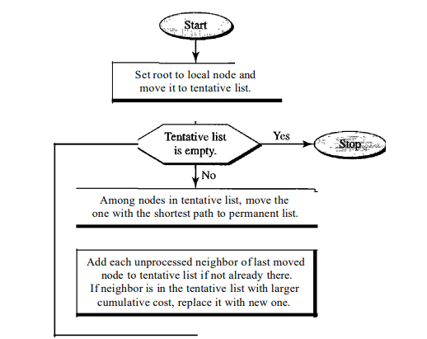
- A shortest path tree is a tree in which the path between the root and every other node is the shortest.
- A tree is a graph of nodes and links; one node is called the root. All other nodes can be reached from the root through only one single route.
- The Dijkstra algorithm creates a shortest path tree from a graph. The algorithm divides the nodes into two sets: tentative and permanent.
- It finds the neighbors of a current node, makes them tentative, examines them, and if they pass the criteria, makes them permanent.
4. Calculation of Routing Table from Shortest Path Tree:
- Each node uses the shortest path tree protocol to construct its routing table.

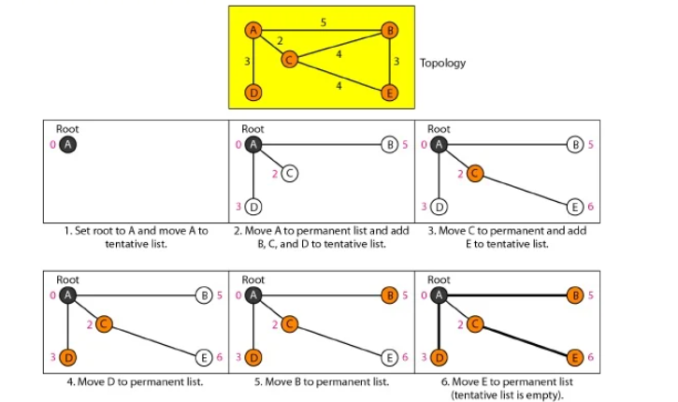
1. Make node A the root of the tree and move it to the tentative list. The two lists are Permanent list: empty Tentative list: A(0)
2. Node A has the shortest cumulative cost from all nodes in the tentative list. Move A
to the permanent list and add all neighbors of A to the tentative list. The new lists are
Permanent list: A(0) Tentative list: B(5), C(2), D(3)
3. Node C has the shortest cumulative cost from all nodes in the tentative list. Move
C to the permanent list. Node C has three neighbors, but node A is already processed, B is already in the tentative list with a cumulative cost of 5. Node A could also reach node B
through C with a cumulative cost of 6. Since 5 is less than 6, we keep node B with a
cumulative cost of 5 in the tentative list and do not replace it. Our new lists are
Permanent list: A(O), C(2) Tentative list: B(5), D(3), E(6)
4. Node D has the shortest cumulative cost of all the nodes in the tentative list.
Move D to the permanent list. Node D has no unprocessed neighbor to be added to
the tentative list.
Permanent list: A(O), C(2), D(3) Tentative list: B(5), E(6)
5. Node B has the shortest cumulative cost of all the nodes in the tentative list.
Move B to the permanent list and add all unprocessed neighbors of B to the
tentative list (this is just node E). E(6) is already in the list with a smaller
cumulative cost. The cumulative cost to node E, as the neighbor of B, is 8. keep
node E(6) in the tentative list. The new lists are
Permanent list: A(O), B (5), C(2), 0(3) Tentative list: E(6)
6. Node E has the shortest cumulative cost from all nodes in the tentative list.
Move E to the permanent list. Node E has no neighbor. Now the tentative list is
empty. The final lists are
Permanent list: A(O), B(5), C(2), D(3), E(6) Tentative list: empty
- The routing table shows the cost of reaching each node from the root.
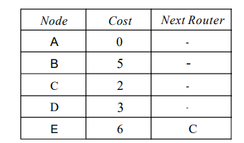
4.4 Open shortest path first Routing (OSPF):(Q5(B)- Explain in detail the operation of OSPF protocol by considering a suitable network.)
- The Open Shortest Path First or OSPF protocol is an intradomain routing protocol based on link state routing. Its domain is also an autonomous system.
- Areas:To handle routing efficiently and in a timely manner, OSPF divides an autonomous system into areas. An area is a collection of networks, hosts, and routers all contained within an autonomous system.
- An autonomous system can be divided into many different areas. All networks inside an area must be connected.
- Routers inside an area flood the area with routing information. At the border of an area, special routers called area border routers summarize the information about the area and send it to other areas.
- Among the areas inside an autonomous system is a special area called the backbone; all the areas inside an autonomous system must be connected to the backbone. In other words, the backbone serves as a primary area and the other areas as secondary areas. This does not mean that the routers within areas cannot be connected to each other, however. The routers inside the backbone are called the backbone routers. A backbone router can also be an area border router.
- If, because of some problem, the connectivity between a backbone and an area is broken, a virtual link between routers must be created by an administrator to allow continuity of the functions of the backbone as the primary area.
- Each area has an area identification. The area identification of the backbone is zero.
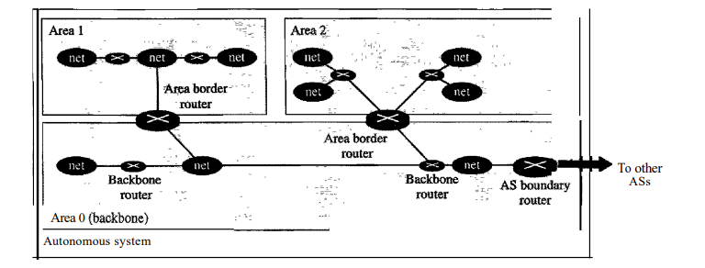
Metric: The OSPF protocol allows the administrator to assign a cost, called the metric,
to each route. The metric can be based on a type of service (minimum delay, maximum
throughput, and so on).A router can have multiple routing tables, each based on a different type of service.
Types of Links: In OSPF terminology, a connection is called a link. Four types of links have been defined: point-to-point, transient, stub, and virtual
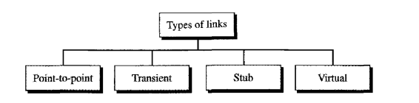
- Point to point link: A point-to-point link connects two routers without any other host or router in between. An example of this type of link is two routers connected by a telephone line or a T line. There is no need to assign a network address to this type of link. Graphically, the routers are represented by nodes, and the link is represented by a bidirectional edge connecting the nodes.

- Transient Link: A transient link is a network with several routers attached to it. The data can enter through any of the routers and leave through any router. All LANs and some WANs with two or more routers are of this type. In this case, each router has many neighbors. For example, Router A has routers B, C, D, and E as neighbors. Router B has routers A, C, D, and E as neighbors.
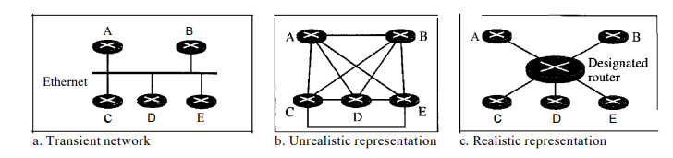
- This is neither efficient nor realistic. It is not efficient because each router needs to advertise the neighborhood to four other routers, for a total of 20 advertisements.
- It is not realistic because there is no single network (link) between each pair of routers; there is only one network that serves as a crossroad between all five routers.
- To show that each router is connected to every other router through one single network, the network itself is represented by a node. One of the routers in the network takes this
responsibility. It is assigned a dual purpose; it is a true router and a designated router.
- Now each router has only one neighbor, the designated router (network). The designated router (the network) has five neighbors. Thc number of neighbor announcements is reduced from 20 to 10.
- Stub Link: A stub link is a network that is connected to only one router. The data packets enter the network through this single router and leave the network through this same router. The link is only one-directional, from the router to the network.
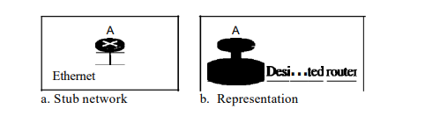
- Virtual Link: When the link between two routers is broken, the administration may create a virtual link between them, using a longer path that probably goes through several routers.
- Graphical Representation: Consider a small AS with seven networks and six routers. Two of the networks are point-to-point networks. The symbols Nl and N2 denote transient and stub networks. There is no need to assign an identity to a point-to point network. The square nodes are used to denote the routers and ovals for the networks. OSPF sees both as nodes. The representation have three stub networks.
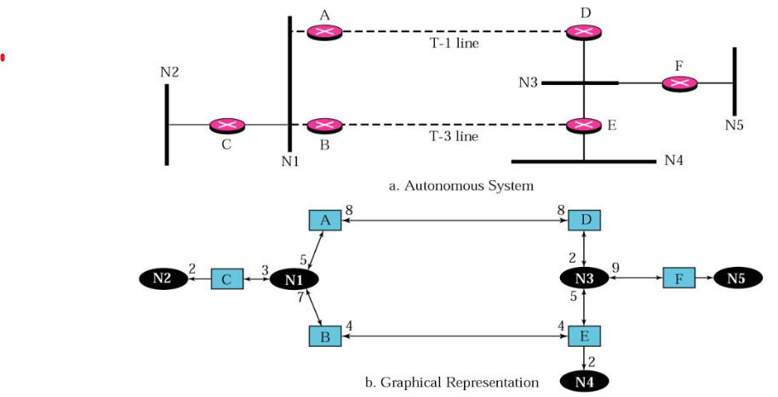
4.4. Path vector routing:
- Path vector routing is an interdomain routing mechanism and is similar to that of distance vector routing.
- In path vector routing, there is one node in each autonomous system that acts on behalf of the entire autonomous system. It is called as the speaker node.
- The speaker node in an AS creates a routing table and advertises it to speaker nodes in the neighboring ASs.
- A speaker node advertises the path, not the metric of the nodes, in its autonomous system or other autonomous systems.

Initialization:
- At the beginning, each speaker node can know only the reachability of nodes inside its autonomous system.
- Node Al is the speaker node for ASl, Bl for AS2, Cl for AS3, and Dl for AS4.
- Node Al creates an initial table that shows Al to A5 are located in AS1 and can be reached through it.
- Node Bl advertises that Bl to B4 are located in AS2 and can be reached through Bl. and so on.
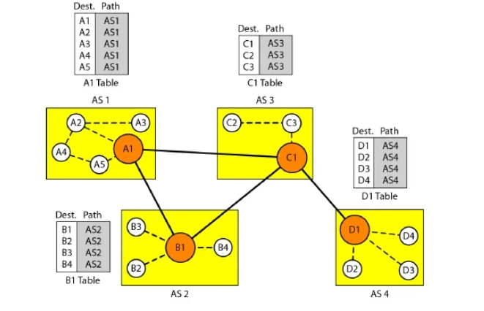
Sharing:
- A speaker in an autonomous system shares its table with immediate neighbors.
- Al shares its table with nodes Bl and Cl.
- Node Cl shares its table with nodes Dl, Bl, and Al.
- Node Bl shares its table with Cl and Al.
- Node Dl shares its table with Cl.
Updating:
- When a speaker node receives a two-column table from a neighbor, it updates its own table by adding the nodes that are not in its routing table and adding its own autonomous system and the autonomous system that sent the table.
- For example, if router Al receives a packet for nodes A3, it knows that the path is in AS1(the packet is at home); but if it receives a packet for Dl, it knows that the packet should go from ASl, to AS3, and then to AS4.
- The routing table shows the path completely. On the other hand, if node Dl in AS4 receives a packet for node A2, it knows it should go through AS4, AS3, and AS 1.
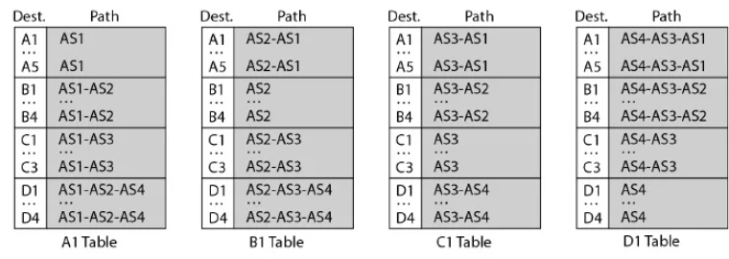
Advantages of Path vector routing:
Loop prevention:
- The instability of distance vector routing and the creation of loops can be avoided in path vector routing. When a router receives a message, it checks to see if its autonomous system is in the path list to the destination. If it is, looping is involved and the message is ignored.
Policy routing:
- Policy routing can be easily implemented through path vector routing. When a router receives a message, it can check the path.
- If one of the autonomous systems listed in the path is against its policy, it can ignore that path and that destination. It does not update its routing table with this path, and it does not send this message to its neighbors.
Optimum path:
- The optimum path is a path to a destination that is the best for the organization that runs the autonomous system.
- The optimum path is the path that fits the organization.
- Each autonomous system may have more than one path to a destination. For example, a path from AS4 to AS1 can be AS4-AS3-AS2-AS1, or it can be AS4-AS3-ASI.
- For the tables, we chose the one that had the smaller number of autonomous systems, but this is not always the case. Other criteria, such as security, safety, and reliability, can also be applied.
4.5 Border gateway protocol:(Q3(B)- Explain about the inter domain routing (BGP) routing algorithms.)
- Border Gateway Protocol (BGP) is an interdomain routing protocol using path vectorA routing.
- The Internet is divided into hierarchical domains called autonomous systems.
- A local ISP that provides services to local customers is an autonomous system.
- The autonomous systems are divided into three categories: stub, multihomed, and transit.
Stub AS: (Single homed)
- A stub AS has only one connection to another AS. The interdomain data traffic in a stub AS can be either created or terminated in the AS.
- The hosts in the AS can send data traffic to other ASs.
- The hosts in the AS can receive data coming from hosts in other ASs.
- Data traffic cannot pass through a stub AS.
- A stub AS is either a source or a sink.
- An example of a stub AS is a small corporation or a small local ISP.
Multihomed AS:
- A multihomed AS has more than one connection to other ASs, but it is still only a source or sink for data traffic.
- It can receive data traffic from more than one AS. It can send data traffic to more than one AS, but there is no transient traffic.
- It does not allow data coming from one AS and going to another AS to pass through. A good example of a multihomed AS is a large corporation that is connected to more than one regional or national AS that does not allow transient traffic.
Transit AS: (Acts as a link between two autonomous systems)
- A transit AS is a multihomed AS that also allows transient traffic.
- Examples of transit ASs are national and international ISPs (Internet backbones).

Path Attributes:
- A path for a destination network is presented as a list of autonomous systems, but it is in fact a list of attributes.
- Each attribute gives some information about the path. The list of attributes helps the receiving router make a more-informed decision when applying its policy.
- Attributes are divided into two broad categories:
  - well known and
  - optional.
- A well-known attribute is one that every BGP router must recognize. An optional attribute is one that needs not be recognized by every router.
- Well-known attributes are themselves divided into two categories:
  - mandatory and
  - discretionary.
- A well-known mandatory attribute is one that must appear in the description of a route. A well
- -known discretionary attribute is one that must be recognized by each router, but is not required to be included in every update message.
- One well known mandatory attribute is ORIGIN. This defines the source of the routing information (RIP, OSPF, and so on).
- Another well-known mandatory attribute is NEXT-HOP, which defines the next router to which the data packet should be sent.
- The optional attributes can also be subdivided into two categories:
  - Transitive and
  - Nontransitive.
- An optional transitive attribute is one that must be passed to the next router by the router that has not implemented this attribute.
- An optional nontransitive attribute is one that must be discarded if the receiving router has not implemented it.
BGP Sessions:
- The exchange of routing information between two routers using BGP takes place in a session.
- A session is a connection that is established between two BGP routers only for the sake of exchanging routing information.
- To create a reliable environment, BGP uses the services of TCP. In other words, a session at the BGP level, as an application program, is a connection at the TCP level.
- However, there is a subtle difference between a connection in TCP made for BGP and other application programs.
- When a TCP connection is created for BGP, it can last for a long time, until something unusual happens. For this reason, BGP sessions are sometimes referred to as semi-permanent connections.
- BGP can have two types of sessions:
  - External BGP (E-BGP) and
  - Internal BGP (I-BGP) sessions.
- The E-BGP session is used to exchange information between two speaker nodes belonging to two different autonomous systems.
- The I-BGP session, on the other hand, is used to exchange routing information between two routers inside an autonomous system.
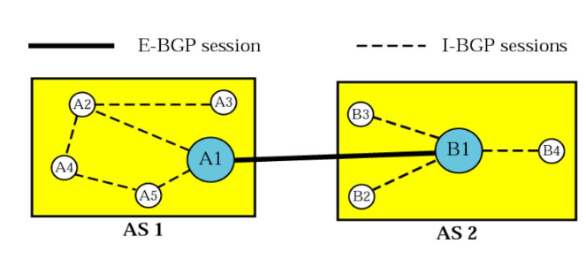
- The session established between AS1 and AS2 is an E-BOP session.
- The two speaker routers exchange information they know about networks in the Internet.
- However, these two routers need to collect information from other routers in the autonomous systems. This is done using I-BOP sessions.

4.6 MULTICAST ROUTING:
- Multicast is a method of group communication where the sender sends data to multiple receivers or nodes present in the network simultaneously.
- Multicasting is a type of one-to-many and many-to-many communication as it allows sender or senders to send data packets to multiple receivers at once across LANs or WANs.
- This process helps in minimizing the data frame of the network because at once the data can be received by multiple nodes. The idea of optimal routing, is common in all multicast protocols.
Optimal Routing: Shortest Path Trees
- The process of optimal interdomain routing results in the finding of the shortest path tree.
- The root of the tree is the source, and the leaves are the potential destinations.
- The path from the root to each destination is the shortest path.
- A multicast packet may have destinations in more than one network.
- Forwarding of a single packet to members of a group requires shortest path tree.
- If we have n groups, we may need n shortest path trees.
- Two approaches have been used to solve the complexity of multicast routing.:
- Source-based trees and
- Group-shared trees
Source-Based Tree.
- In the source-based tree approach, each router needs to have one shortest path tree for each group.
- The shortest path tree for a group defines the next hop for each network that has loyal member(s) for that group.
- For example assume that we have only five groups in the domain: GI, G2, G3, G4, and G5.
- At the moment GI has loyal members in four networks, G2 in three, G3 in two, G4 in two, and G5 in two.
- There is one shortest path tree for each group; Hence, there are five shortest path trees for five groups.
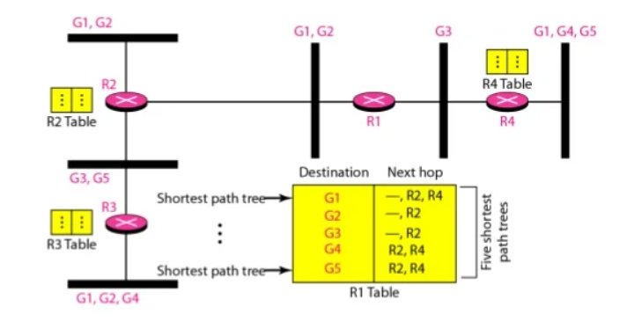
- If router Rl receives a packet with destination address G1, it needs to send a copy of the packet to the attached network, a copy to router R2, and a copy to router R4 so that all members of G1 can receive a copy.
- In this approach, if the number of groups is m, each router needs to have m shortest path trees, one for each group.
Group shared Trees:
- In the group-shared tree approach, instead of each router having m shortest path trees, only one designated router, called the center core, or rendezvous router, takes the responsibility of distributing multicast traffic.
- The core has m shortest path trees in its routing table. The rest of the routers in the domain have none.
- If a router receives a multicast packet, it encapsulates the packet in a unicast packet and sends it to the core router. The core router removes the multicast packet from its capsule, and consults its routing table to route the packet.
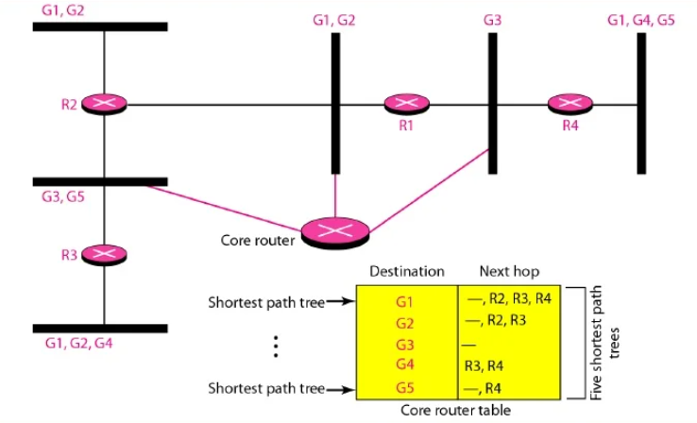
Multicast Routing Protocols:
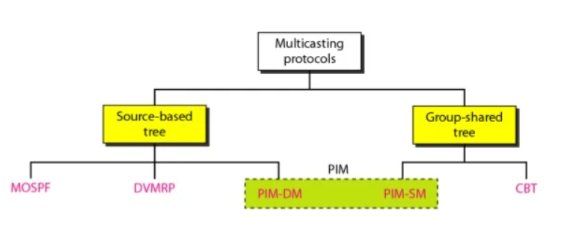
4.7 Distance vector multicast Routing protocol:
- Multicast routing does not allow a router to send its routing table to its neighbors.
- The idea is to create a table from scratch by using the information from the unicast distance vector tables.
- Multicast distance vector routing uses source-based trees, but the router never actually makes a routing table.
- When a router receives a multicast packet, it forwards the packet as though it is consulting a routing table.
- We can say that the shortest path tree is evanescent. After its use (after a packet is forwarded) the table is destroyed.
- To accomplish this, the multicast distance vector algorithm uses a process based on four decision-making strategies.
  - Flooding
  - Reverse path forwarding
  - Reverse path broadcasting
  - Reverse path multicasting
Flooding:
- Flooding broadcasts packets, but creates loops in the systems.
- A router receives a packet and, without even looking at the destination group address, sends it out from every interface except the one from which it was received.
- Flooding accomplishes the first goal of multicasting: every network with active members receives the packet. However, so will networks without active members. This is a broadcast, not a multicast. There is another problem: it creates loops.
- A packet that has left the router may come back again from another interface or the same interface and be forwarded again. Some flooding protocols keep a copy of the packet for a while and discard any duplicates to avoid loops.
Reverse path forwarding:
- RPF is a modified flooding strategy.
- To prevent loops, only one copy is forwarded; the other copies are dropped.
- In RPF, a router forwards only the copy that has travelled the shortest path from the source to the router.
- To find this copy, RPF uses the unicast routing table. The router receives a packet and extracts the source address (a unicast address).
- It consults its unicast routing table as though it wants to send a packet to the source address. The routing table tells the router the next hop.
- If the multicast packet has just come from the hop defined in the table, the packet has travelled the shortest path from the source to the router because the shortest path is reciprocal in unicast distance vector routing protocols.
- If the path from A to B is the shortest, then it is also the shortest from B to A. The router forwards the packet if it has travelled from the shortest path; it discards it otherwise. This strategy prevents loops because there is always one shortest path from the source to the router.
- If a packet leaves the router and comes back again, it has not travelled the shortest path.
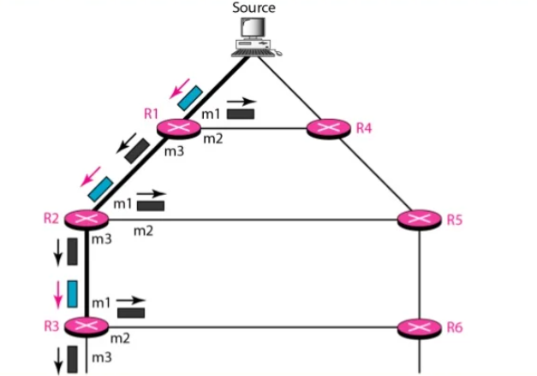
- The shortest path tree as calculated by routers R1, R2, and R3 is shown by a thick line.
- When R1 receives a packet from the source through the interface m1, it consults its routing table and finds that the shortest path from R1 to the source is through interface m1. The packet is forwarded.
- If a copy of the packet has arrived through interface m2, it is discarded because m2 does not define the shortest path from RI to the source.
Reverse Path Broadcasting:
- RPF guarantees that each network receives a copy of the multicast packet without formation of loops.
- RPF does not guarantee that each network receives only one copy; a network may receive two or more copies.
- The reason is that RPF is not based on the destination address (a group address); forwarding is based on the source address.
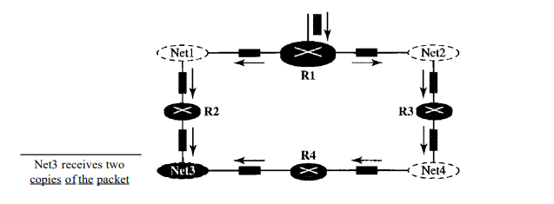
- Net3 in this figure receives two copies of the packet even though each router just sends out one copy from each interface. There is duplication because a tree has not been made; instead of a tree we have a graph.
- Net3 has two parents: routers R2 andR4.
- To eliminate duplication, we must define only one parent router for each network. We must have this restriction: A network can receive a multicast packet from a particular source only through a designated parent router.
- Now the policy is clear. For each source, the router sends the packet only out of those interfaces for which it is the designated parent.
- This policy is called reverse path broadcasting (RPB). RPB guarantees that the packet reaches every network and that every network receives only one copy.

Reverse path Multicasting:
- RPB does not multicast the packet, it broadcasts it. This is not efficient. To increase efficiency, the multicast packet must reach only those networks that have active members for that particular group. This is called reverse path multicasting (RPM).
- To convert broadcasting to multicasting, the protocol uses two procedures, pruning and grafting.
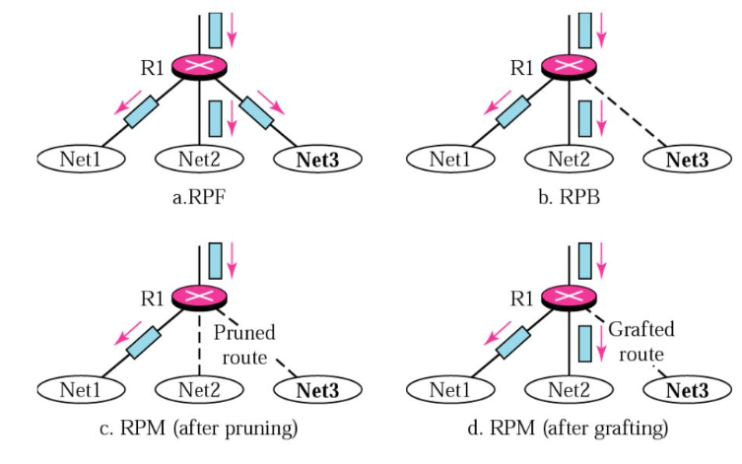
- The designated parent router of each network is responsible for holding the membership information. This is done through the IGMP protocol.
- The process starts when a router connected to a network finds that there is no interest in
a multicast packet.
- The router sends a prune message to the upstream router so that itcan exclude the corresponding interface. That is, the upstream router can stop sending multicast messages for this group through that interface.
- Now if this router receives prune messages from all downstream routers, it, in turn, sends a prune message to its upstream router.
- If a leaf router (a router at the bottom of the tree) has sent a prune message but suddenly realizes, through IGMP, that one of its networks is again interested in receiving the multicast packet then it can send a graft message.
- The graft message forces the upstream router to resume sending the multicast messages.
4.8 PIM – Protocol Independent Multicast:( Q6(B)Explain PIM multicast routing in detail.)
- PIM (Protocol Independent Multicast) is a multicast routing protocol, that is used to send traffic from a single source to multiple destinations across a network.
- PIM is a collection of three protocols - PIM Sparse Mode, PIM Dense Mode and PIM Bi-directional.
- PIM is termed protocol-independent because PIM does not include its own topology discovery mechanism, but instead uses routing information supplied by other routing protocols.
PIM Components:
- In order for multicast traffic to be sent through a network, there are two key elements - state and the multicast distribution tree.
State: State is the information network devices must track in order for the router to know where it should send the traffic. State includes the component known as (S, G); S (multicast source), G (multicast group).
Distribution Tree: The distribution tree is a path through the network used to distribute multicast traffic. There are two types of distribution trees - shortest path (also known as source tree) and shared.
i) Source Distribution tree:
- The Shortest Path (Source) Distribution tree is simply the shortest path from the source to the multicast group member. Because it represents an optimal path, a source distribution tree minimizes the latency in the network.
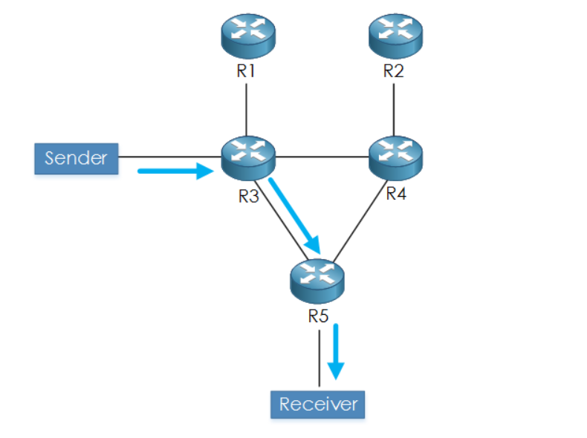
ii) Shared Distribution Tree
- The source trees that have their root at the source, where the shared trees use a single common root, called a Rendezvous Point (RP) as the root of the distribution tree.
- Other routers do not need to know the addresses of the sources for every multicast group. All they need to know is the IP address of the RP router. The RP router discovers the sources for all multicast groups.
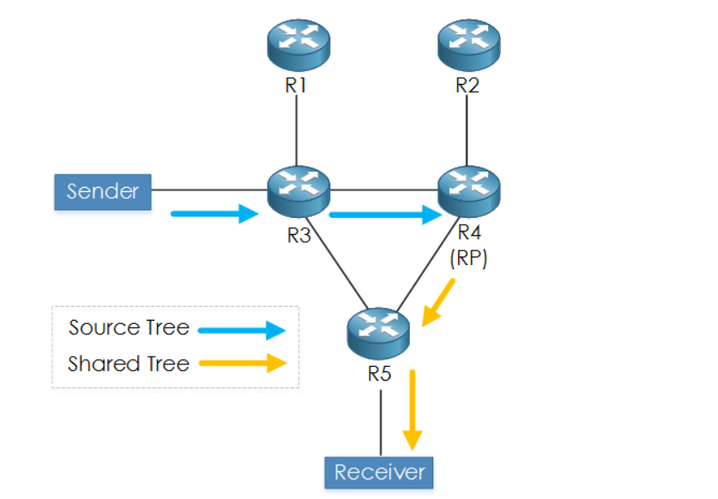
PIM Protocols:
1. PIM Dense-Mode
- PIM Dense Mode operates by initially flooding the multicast traffic for all groups out of all enabled interfaces
- Routers that do not have any interested hosts send PIM Prune messages to remove themselves from the tree .
- Based on this “Flood and Prune” behaviour, eventually, the traffic is only sent to the necessary routers that require the traffic. This, in turn, results in a source distribution tree
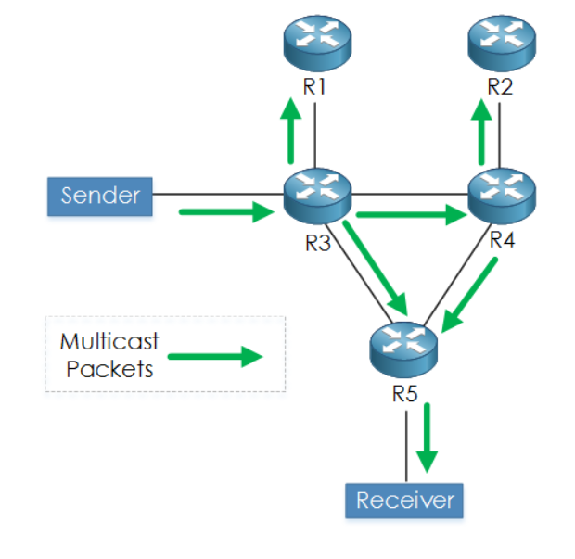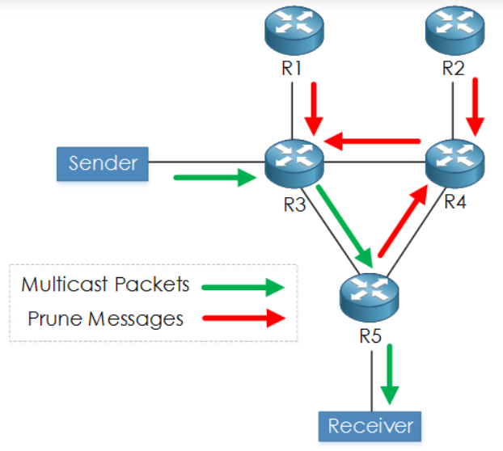
PIM-DM Flooding ; (S, G). PIM-DM Pruning
- Because of PIM-DMs "Flood and Prune" model, and the disadvantages that come with it, PIM-DM is only recommended for large-scale networks or lab-based environments.
2. PIM Sparse-Mode
- PIM-SM works inv the opposite manner to PIM-DM; with PIM sparse mode no multicast traffic is forwarded unless some requests it. PIM-SM works via the use of an RP (Rendezvous Point).
Process that PIM-SM takes:
1. Shared Tree (RP to Receiver) - The receiver sends an IGMP Join message to the first hop router (FHR), i.e. its direct neighboring router. This router will then send a PIM Join to the RP. A shared tree is then built from the receiver to RP based upon (*, G).
2. Shortest Path Tree (Source to RP) - Next, the source starts to send multicast traffic. The FHR encapsulates the multicast packet into a PIM register message and sends via unicast to the RP router.
The RP decapsulates the packet and checks the multicast group to see if it has any state for any receivers for the multicast group. If so the RP sends a PIM Join message back towards the source, in order to build an SPT (Shortest Path Tree) back to the source.
The source sends another multicast packet, however now there is a SPT (aka source tree) from the RP to the FHR. Therefore the packet is now sent across the distribution tree to the RP. The RP receives the packet nativity (with S, G), and in turn, sends a register-stop message back to the sources FHR to stop receiving the register messages (via unicast).
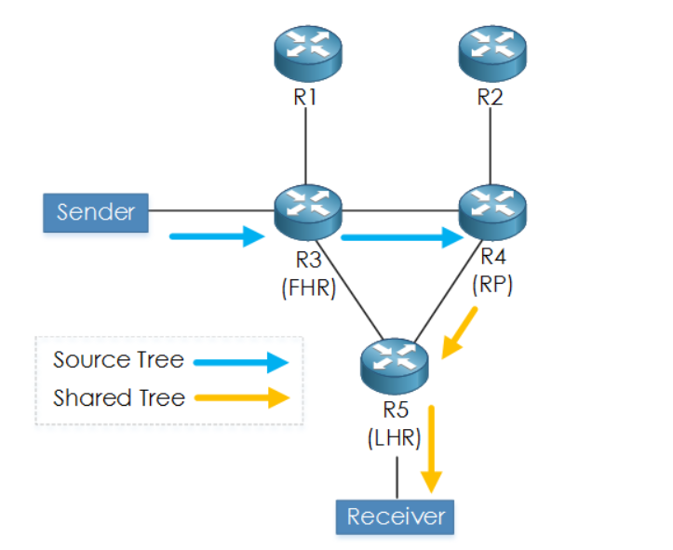
3. PIM- Bidirectional (Shortest Path Tree Switchover):
- The LHR sees the source address of the multicast stream. Now that the LHR knows the source address, it sends an (S, G) Join to the source of the multicast stream.
- This builds an SPT from LHR to FHR. Finally, a Prune message is sent from the LHR to the RP in order to remove the previously used (RP to LHR) shared tree.

Q4(B).What are the different routing algorithms? List out their pros and cons.
1.Distance Vector Routing

Protocols:
- RIP (Routing Information Protocol)
Description: Nodes share their routing tables with immediate neighbors. Each router updates its table based on information from neighbors, and the process continues periodically.
Pros:
- Simplicity: Easy to configure and implement.
- Low resource consumption: Requires minimal memory and CPU power.

Cons:
- Slow convergence: Can take time to propagate changes through the network, leading to potential routing loops.
- Count-to-infinity problem: Routers may incorrectly think unreachable nodes are reachable for an extended time.

Use case: Small to medium-sized networks.

2. Link State Routing

Protocols:
- OSPF (Open Shortest Path First)
Description: Each router shares information about its immediate neighbors with all other routers. This allows each router to build a full map of the network and use Dijkstra’s algorithm to find the shortest path.

Pros:
- Faster convergence : Quickly updates routing tables when there are changes in the network.
-Loop-free: Uses complete topology information, avoiding loops.

Cons:
- Resource-intensive : Requires more memory and CPU power to maintain a complete map of the network.
- More bandwidth usage: Frequent link-state advertisements consume bandwidth.

Use case: Large, complex networks where speed and efficiency are required.

3. Path Vector Routing

Protocols:
- BGP (Border Gateway Protocol)

Description:Routers maintain paths to each destination, recording the route that data will take rather than just the next hop. Typically used in inter-domain routing.

Pros:
- Loop prevention : The path information helps avoid loops, as each router can determine the exact path.
- Policy-based routing :Allows for routing decisions based on specific policies (e.g., preferring certain ISPs).

Cons:
- Complexity: BGP configuration and maintenance are more complex.
- Slower convergence: BGP convergence can be slower, especially in large, dynamic networks.

Use case: Internet-scale or large networks (e.g., between ISPs).

4. Flooding
Protocols:
- No specific protocol for traditional IP routing (but similar methods may be used in routing broadcast or multicast packets).

Description: Each packet received by a node is sent out on all outgoing links, except the one it arrived on. No routing table is needed.

Pros:
- Guaranteed delivery: Packets reach all destinations if any path exists.
- No complex computation: Doesn’t require complicated path calculations.
Cons:
- Inefficient: Leads to many duplicate packets, wasting bandwidth and processing power.
- Network congestion: Can overwhelm network resources quickly due to excessive duplication.
Use case: Rare in IP routing but can be used in ad-hoc networks or in small, simple topologies.

5. Multicasting
Protocols:
- PIM (Protocol Independent Multicast)
Description: Multicasting allows one sender to send data to multiple receivers in a group. Routers only send copies of the message to relevant parts of the network where group members are located, reducing traffic.

Pros:

- Efficient bandwidth usage: Only sends data where it is needed, avoiding duplication of streams.
- Scalability: Can handle large groups of receivers without overwhelming the sender.

Cons:

- Complex configuration: Setting up and managing multicast groups can be complex.
- Not widely supported: Some networks and ISPs may not support multicast traffic, limiting its effectiveness.

Use case: Video streaming, live broadcasting, and online conferencing where data needs to be distributed to multiple recipients simultaneously.

PART - C
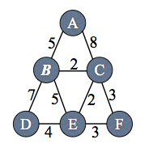
Consider the network shown in the picture below. Each node implements Dijkstra's shortest path algorithm using the link costs shown in the picture.
- Node B's routing table contains only one entry, for itself. When B runs Dijkstra's algorithm, in what order are nodes added to the routing table? List all possible answers.
Now suppose the link cost for one of the links changes but all costs remain non-negative. For each change in link cost listed below, state whether it is possible for the route at node B (i.e., the link used by B) for any destination to change, and if so, name the destination(s) whose routes may change.
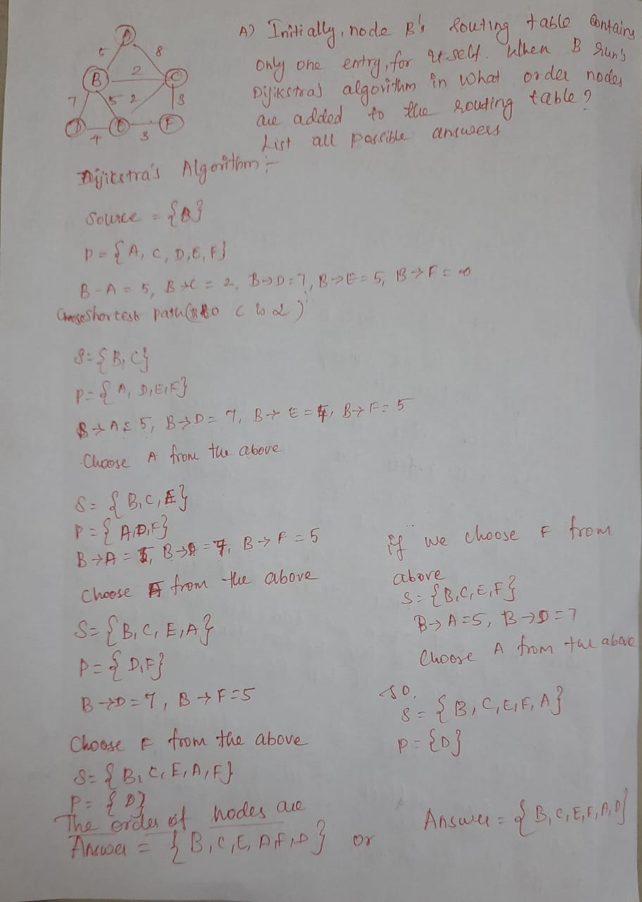
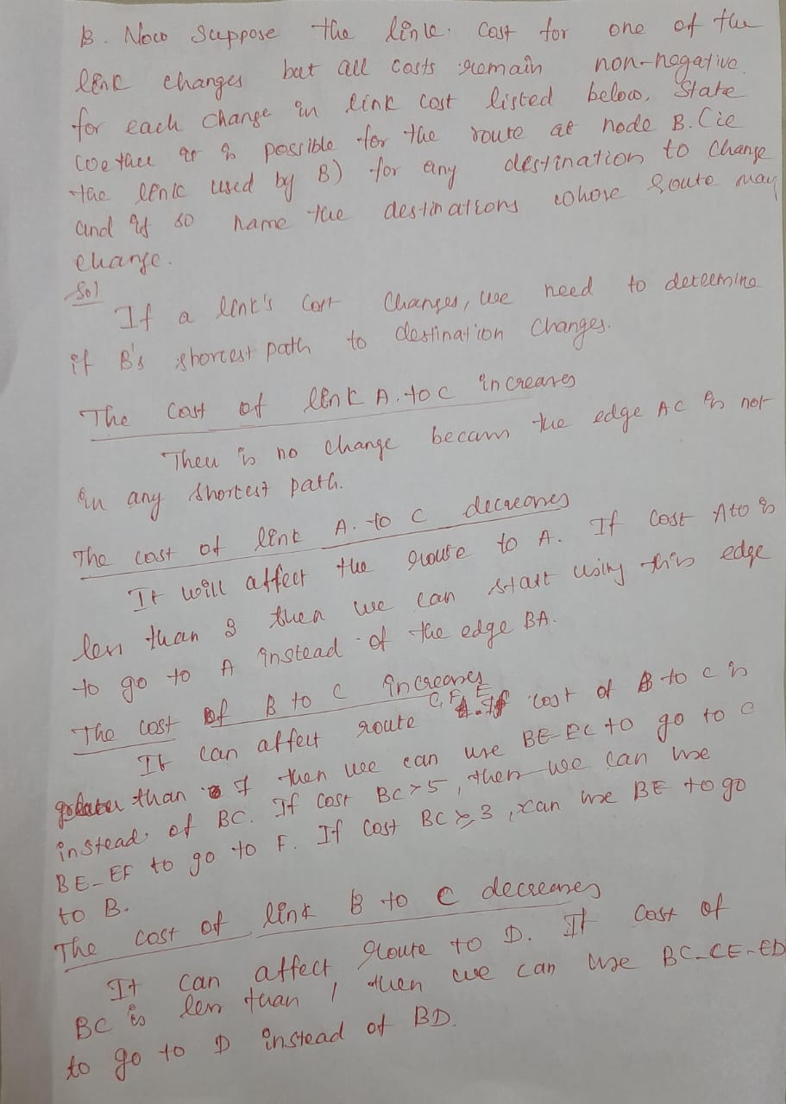

- Analyze the Link State algorithm in detail. (4)
(ii) Consider the network shown in Fig 1. Compute the shortest path from C to all other Nodes using Link-State algorithm. Also update the forwarding table of node C. (9)

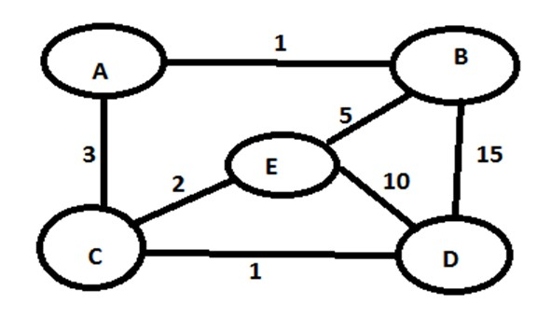
- Flooding of Link-State Information: Each node sends out its link-state packet (LSP), which contains information about all of its directly connected neighbors and the associated link costs. These packets are flooded throughout the entire network so that each node gets a complete map of the network topology.
- Building the Network Topology: Once every node has the complete network information, they all know about the entire network's topology. This information is stored in each node’s Link-State Database (LSDB).
- Dijkstra’s Algorithm: Each node uses Dijkstra’s shortest path algorithm to compute the shortest path from itself to every other node in the network. The algorithm works by:
  - Setting the distance to itself as zero and the distance to all other nodes as infinity initially.
  - Selecting the neighbor with the smallest distance.
  - Updating the path costs to the other nodes as new paths are discovered.
  - Repeating the process until the shortest path to all nodes is found.

Example with Diagram
In the given diagram, nodes (A, B, C, D, E) are connected by links with different weights. Here is how the Link State algorithm would work:
- Node E’s Initial Knowledge: Node E knows the costs to nodes A (2), B (5), C (2), and D (10).
- LSP Flooding: Node E floods this information to all other nodes. Similarly, nodes A, B, C, and D will also flood their own information about their directly connected neighbors. After this flooding process, all nodes will have complete knowledge of the network’s topology.
- Dijkstra’s Algorithm (Node E as Source): To calculate the shortest path from node E to all other nodes using Dijkstra's algorithm:
  - Start with E (distance 0).
  - The directly connected nodes are A (cost 2), C (cost 2), B (cost 5), and D (cost 10).
  - Choose node A and C (cost 2) since they have the lowest costs.
  - From A, the only other node is B (cost 1). So the total cost from E to B via A is 2 + 1 = 3.
  - From C, we can go to D with a cost of 1, so the total cost from E to D via C is 2 + 1 = 3.
  - The shortest path tree would then be:
    - E to A: cost 2
    - E to C: cost 2
    - E to B: cost 3 (via A)
    - E to D: cost 3 (via C)
Thus, node E computes the shortest paths to all other nodes.
To compute the shortest path from node C to all other nodes using the Link-State Algorithm (Dijkstra's Algorithm), we will follow these steps:

Given Graph (Weights between nodes):
- C to A: 3
- C to E: 2
- C to D: 1
- A to B: 1
- E to A: 2
- E to B: 5
- E to D: 10
- D to B: 15

Step-by-Step Execution of Dijkstra's Algorithm:
- Initialization:
  - Starting at node C.
  - Distance to C = 0.
  - Distance to all other nodes is set to infinity.
  - The unvisited set contains all nodes: {A, B, C, D, E}.
- Visiting Node C:
  - Current node: C, Distance = 0.
  - Neighbors of C:
    - A: Distance = 3.
    - E: Distance = 2.
    - D: Distance = 1.
  - Update distances:
    - Distance to A = 3.
    - Distance to E = 2.
    - Distance to D = 1.
  - Mark C as visited. Unvisited set: {A, B, D, E}.
- Visiting Node D (shortest distance from C):
  - Current node: D, Distance = 1.
  - Neighbors of D:
    - B: Distance to B via D = 1 + 15 = 16.
    - E: Distance to E via D = 1 + 10 = 11 (but already have a shorter distance of 2).
  - No updates for E or B, as shorter paths already exist.
  - Mark D as visited. Unvisited set: {A, B, E}.
- Visiting Node E (next shortest distance):
  - Current node: E, Distance = 2.
  - Neighbors of E:
    - A: Distance to A via E = 2 + 2 = 4 (but already have a shorter path of 3).
    - B: Distance to B via E = 2 + 5 = 7.
  - Update distance to B = 7.
  - Mark E as visited. Unvisited set: {A, B}.
- Visiting Node A (next shortest distance):
  - Current node: A, Distance = 3.
  - Neighbors of A:
    - B: Distance to B via A = 3 + 1 = 4.
  - Update distance to B = 4.
  - Mark A as visited. Unvisited set: {B}.
- Visiting Node B (last unvisited node):
  - Current node: B, Distance = 4.
  - No unvisited neighbors.
  - Mark B as visited. Unvisited set: {}.

Final Shortest Paths from Node C:
- Distance from C to A = 3.
- Distance from C to B = 4.
- Distance from C to D = 1.
- Distance from C to E = 2.

Shortest Paths:
- C → D: cost 1.
- C → E: cost 2.
- C → A: cost 3 (via E).
- C → B: cost 4 (via A).

Forwarding Table for Node C:
The forwarding table of node C will list the next hop to reach each destination:
Destination | Next Hop | Cost
A | E | 3
B | A | 4
C | - | 0
D | D | 1
E | E | 2
This forwarding table ensures that node C sends packets along the shortest path to each destination.

Summary of the Shortest Path from C:
- To A: C → E → A (cost 3).
- To B: C → E → A → B (cost 4).
- To D: C → D (cost 1).
- To E: C → E (cost 2).
This is the result of running Dijkstra’s algorithm and creating the forwarding table based on the shortest paths.

